**Projected Doctor Deficit in Germany and Its Impact on Africa (2024-2044)**

**Executive Summary**

This report analyzes the projected doctor deficit in Germany over the next two decades and examines its potential implications for African countries. Using [data](https://docs.google.com/spreadsheets/d/1NYCX7hc9v_EliVZNoqJlSUiOM5lSRpmn/edit?usp=drive_link&ouid=117862026297900942934&rtpof=true&sd=true) on current doctor numbers, retirement trends, and medical graduate rates, a significant shortfall in medical professionals in Germany by 2044 is projected. This deficit could lead to increased recruitment of doctors from Africa, potentially impairing healthcare challenges in African nations.

**Data Sources:**

* Data was obtained from [Eurostat](https://ec.europa.eu/eurostat), German Federal Statistical Office [Destatis](https://www.destatis.de/EN/Home/_node.html) and WHO

***Doctors in Germany:*** This dataset provides historical data on the number of active doctors and those without medical activity. It is essential for analyzing the current trend and establishing a baseline for future projections.

***Mean Retirement Age****:* This dataset gives the average retirement age of doctors. It will help estimate the number of doctors retiring each year, a critical factor in projecting future deficits.

***Medical Graduates in Germany***: Contains the number of new medical graduates each year. This data is needed to estimate how many new doctors will enter the workforce annually, helping to offset the number of retiring doctors.

***Population Projection Data:*** Provides projections of the German population over the next 20 years. This is crucial for estimating the required number of doctors based on population growth and maintaining an adequate doctor-to-population ratio.

***African Doctors Migrating to Germany:*** This dataset provides historical data on the number of African doctors moving out of Africa.

The datasets were cleaned and preprocessed and put together in a [**workbook**](https://docs.google.com/spreadsheets/d/1NYCX7hc9v_EliVZNoqJlSUiOM5lSRpmn/edit?usp=drive_link&ouid=117862026297900942934&rtpof=true&sd=true)**.**

**The Analysis** [***(Notebook*)**](https://drive.google.com/file/d/1oyXUSSITB7PMvm50pAXMAaBH-Jc5nPJ6/view?usp=drive_link)

**1. Current Situation in Germany**

* **Number of Doctors**: As of 2023, there are approximately 428,500 doctors in Germany. The number has been on an increase since 1995. However, a significant portion (around 140,300) is not involved in active medical practice.

* **Medical Graduates**: Germany produces about 9,558 new medical graduates each year.

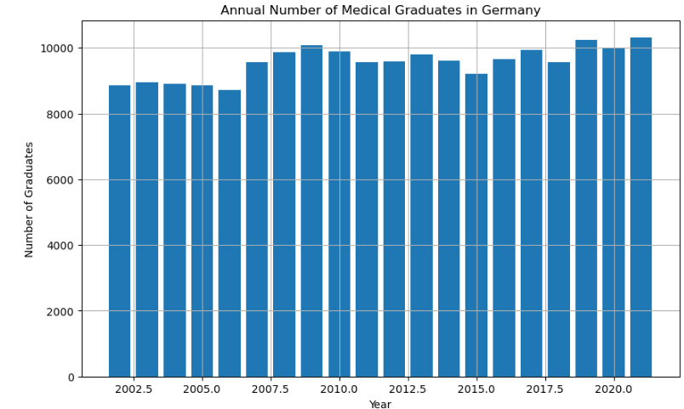

**2. Retirement Trends**

* **Retirement Age**: The standard retirement age is around 67 years. This retirement trend suggests that a significant portion of the current workforce will retire over the next 20 years.

**3. Doctor Deficit Projection**

* **Annual Deficit**: Given that the number of doctors has shown a slight annual decrease historically, combined with retirement trends, Germany could face a growing deficit if the number of new graduates doesn't keep pace with the retiring doctors.

* **Projected Deficit**: Over the next 20 years, unless there is a substantial increase in the number of medical graduates or recruitment of doctors from abroad, Germany might face a significant shortfall in medical professionals.

In 2024, the projection is 422,114 doctors, but by 2043, this number is expected to decrease to 317,367 doctors. This table below shows the deficit in the number of doctors each year compared to the baseline year of 2023.

A negative value indicates how many fewer doctors are projected to be available in a given year compared to 2023.

For example, in 2024, the deficit is -6,386 doctors, meaning there are 6,386 fewer doctors than in 2023. By 2043, the deficit grows to **-111,133 doctors**.

**5. Situation in Africa**

This projection shows the expected growth in the total number of doctors in Germany from Africa over the next 20 years. The projection is based on the historical growth rate, which is Average annual growth rate of doctors: 0.01824061705197662. This means that, on average, the number of doctors in Germany has been growing by about 1.82% annually.

**4. Implications for Africa**

* **Brain Drain**: If Germany recruits doctors from Africa to fill this gap or African Doctors keep migrating, it could worsen the already existing healthcare challenges in many African countries, where medical professionals are scarce as reiterated by [WHO](https://www.who.int/activities/addressing-the-international-migration-of-health-workers).
* **Collaborative Opportunities**: There is potential for Germany to engage in international medical education programs, where African doctors are trained and then return to their home countries, which could benefit both regions.

**The Key Findings**

**Doctor Supply and Demand (Declining Number of Doctors and Increasing Deficit)**

The number of doctors steadily decreases over the 20-year period. This decline could be due to several factors such as high retirement rates, insufficient number of new medical graduates, or possibly emigration of doctors to other countries.

The average annual increase in doctors (5,525) is lower than the number of new graduates (9,558), indicating a significant outflow of medical professionals from active practice. With an aging population and increasing healthcare demands, the need for doctors is likely to grow faster than the current supply.

The deficit compared to 2023 grows significantly over time, from -6,386 in 2024 to a staggering -111,133 by 2043. This indicates a worsening shortage of doctors, which could lead to severe impacts on the healthcare system if not addressed.

**Retirement Wave**

Assuming a retirement age of 67, a large cohort of doctors will retire in the coming two decades. This retirement wave will create a significant gap that new graduates alone may not be able to fill.

**Implications for Healthcare and its Impact on Africa**

**Impact on Africa**

A growing doctor deficit could result in longer wait times, overworked medical staff, and potentially lower quality of care. It could also lead to increased pressure to recruit doctors from other countries, such as those in Africa.

African countries, already facing shortages of medical professionals, may see an increase in doctor emigration to Germany.

Countries like Nigeria, Egypt, and South Africa, which have historically been sources of medical professionals for Western countries, may be particularly affected.

This graph projects the number of African doctors migrating to Germany over the next 20 years. The projection is based on the historical trend and assumes that the proportion of African doctors to total doctors in Germany stays constant. Average ratio of African doctors to total doctors in Germany: 0.004578778107556392. On average, African doctors represent about 0.46% of the total doctors in Germany.

**Recommendations**

1. Germany should consider expanding medical education capacity to increase the number of new doctors entering the workforce annually.

2. Implement policies to encourage doctors to remain in active practice longer and to attract those who have left back into medical service.

3. Develop ethical recruitment policies and collaborative training programs with African countries to mitigate negative impacts on their healthcare systems.

4. Explore the use of nurse practitioners and physician assistants to alleviate some of the pressure on the medical system.

5. Invest in telemedicine and AI-assisted diagnostics to increase the efficiency of the existing medical workforce.

**Conclusion**

The findings suggest that without intervention (e.g., increasing the number of medical graduates, delaying retirement, or improving working conditions to retain doctors), Germany is likely to face a significant healthcare challenge in maintaining an adequate doctor-to-population ratio over the next two decades due to retirements outpacing the inflow of new medical graduates. This situation might lead to increased recruitment of foreign doctors, particularly from Africa, which could have significant implications for healthcare systems in both regions. Proactive strategies, such as increasing the number of medical graduates, retention and international cooperation in medical education, are essential to address this impending crisis while minimizing negative impacts on African healthcare systems.